MARCHING BAND

of
George County
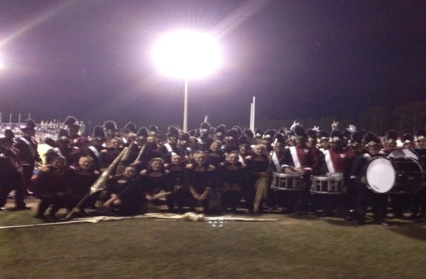
“The Pride” of George County Marching Band is full of energetic young people who love to make music, and get involved in the community. The Marching Band meets for the Fall Semester. “The Pride” performs at all GCHS football games and pep rallies, several parades throughout the year, and a few competitions. In 2014, the marching band earned all Superior ratings at both contests they attended. Being part of the marching band is a lot of work, but very rewarding, as well. After school rehearsals/performances are required, as well as a $100 Band Fee, in order to participate.

CONCERT BAND
The George County High School Symphonic/Concert Band meets during the Spring Semester. These students have the opportunity to really focus on musicianship at a very high level. The Symphonic Band gives a Spring Concert every year, and participates in the Mississippi State Concert Evaluation. Students have the opportunity to audition for several Honor Band Clinics, where they can perform with many of the best high school musicians in our region/state. At the end of the spring, a banquet is held to help celebrate the accomplishments and memories of the hard work that has been invested. We strongly encourage students to participate in both Marching and Concert Band every year, to get the most out of their high school experiences.

JAZZ BAND
The GCHS Jazz Band is a smaller chamber group who focuses on a unique style of literature. Most of these students are self-driven, hard-working, and motivated students. They currently meet after school once a week to prepare for a concert in the spring.

CHOIR / ADVANCED DRAMA
Chorus is a class in which students prepare for performances by learning a variety of concert choir repertoire. Daily practice is required, culminating in local performances at school and different churches.
Drama is a class where students create and perform scripts designed for live performances. The students will have the opportunity to perform at school, and attend various other performances at local colleges.
Both Choir and Advanced Drama are designed for singers and actors who are interested in the performing arts and showcasing their talents.

ART II/ART III/ART IV
These classes are designed to build upon lessons learned in Art I. The students will review and learn new methods and techniques in Art. They will also begin ceramic hand building. Art helps students improve critical thinking skills, decision-making skills, and has proven to help them improve test scores in Math and English.

THE IMPORTANCE OF FINE ARTS EDUCATION
Education in the arts is an integral part of the development of each human being. Those who have studied learning processes throughout the ages, beginning with Plato, have emphasized the importance of the arts in the education process. Arts education refers to education in the disciplines of music, dance, theatre, and visual arts. Study in the arts is integral to our society. They are a part of the cultural heritage of every American. The arts are what make us most human, most complete as people. The arts cannot be learned through occasional or random exposure any more than math or science can. Education and engagement in the fine arts are an essential part of the school curriculum and an important component in the educational development of every student at George County High School.

Sufficient data exists to overwhelmingly support the belief that study and participation in the fine arts is a key component in improving learning throughout all academic areas. Evidence of its effectiveness in reducing student dropout, raising student attendance, developing better team players, fostering a love for learning, improving greater student dignity, enhancing student creativity, and producing a more prepared citizen for the workplace for tomorrow can be found documented in studies held in many varied settings, from school campuses, to corporate America.
The fine arts also provide learners with non-academic benefits such as promoting self-esteem, motivation, aesthetic awareness, cultural exposure, creativity, improved emotional expression, as well as social harmony and appreciation of diversity. These are the very fibers of the fabric known as our American culture.
FINE ARTS PROGRAMS OFFERED
AT GEORGE COUNTY HIGH SCHOOL:
_______________________
*MARCHING BAND
*CONCERT BAND
JAZZ BAND
*CHOIR
PIANO I
INTRO TO MUSIC
INTRO TO THEATER
DRAMA
*ADVANCED DRAMA
ART I
*ART II
*ART III
*ART IV
POTTERY

*Students must complete 3 or more of these classes to fulfill CAAB Academy requirements

FACULTY
Kyle Bozeman-Band Director
Aaron Fiveash-Asst. Band Director
Murry Simmons-Choir/Adv. Drama Director
Shane Skinner-Art Teacher

George County High School 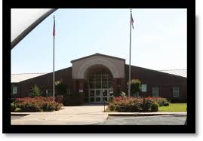

Fine Arts

